

**BAKERZ BITE**

**Supervisor:** *NGUYỄN HẠ VY*

**Semester:** *01*

**Batch No:** *T3.2403.M1*

**Group No:** *03*

|  |  |  |
| --- | --- | --- |
| **Order:** | **Full name** | **Roll No.** |
| *1.* | *NGUYEN HOANG ANH KHOA* | Student1559431 |
| *2.* | *NGO QUANG KHANH* | Student1559589 |
| *3.* | *LE VINH KHANG* | Student1559593 |
| *4.* | *NGUYEN ĐUC HUY* | Student1559421 |

***Month****: 7* ***Year****: 2024*



This is to certify that

**Mr. NGUYEN HOANG ANH KHOA Mr. NGO QUANG KHANH Mr. LE VINH KHANG**

**Mr. NGUYEN ĐUC HUY**

Have successfully Designed & Developed

# BAKERZ BITE

Submitted by:

**Mr. NGUYEN HOANG ANH KHOA**

Date Of Issue:

29 – JULY - 2024

Authorized Signature:

**Mr. NGUYEN HOANG ANH KHOA**

**Acknowledge**

This website design project for Bakerz Bite has been an incredible learning experience. Through this project, I have gained valuable insights into various aspects of web development:

* **Enhanced Technical Skills**: Improved proficiency in HTML, CSS, JavaScript, and React for building responsive and dynamic web pages.
* **User Experience Focus**: Gained understanding of user-centric design principles, enhancing the overall usability and accessibility of the website.
* **Functional Integration**: Learned to incorporate various features such as payment gateways, interactive elements, and navigation systems seamlessly.
* **Problem-Solving Abilities**: Developed strong problem-solving skills by troubleshooting and debugging issues that arose during the design and development phases.
* **Project Management**: Improved project management skills through planning, organizing, and executing tasks effectively within deadlines.
* **Collaboration and Communication**: Enhanced ability to collaborate with team members and communicate effectively with stakeholders to ensure project success.
* **Aesthetic Design**: Cultivated a keen eye for design aesthetics, ensuring that the website is visually appealing and aligns with the brand identity of Bakerz Bite.
* **Real-World Application**: Gained practical experience by working on a real-world project, preparing for future professional challenges in web development.

I would like to extend my heartfelt gratitude to Apptech Education Group for providing this opportunity to showcase and develop my web design skills. Their support has been instrumental in the successful completion of this project.

A special thanks to Ms. Ha Vy for her continuous guidance and assistance throughout the web development process. Her expertise and encouragement have been invaluable to my growth and understanding in this field.

Yours Sincerely, Team Group 03.

**Essential Library Installations**

**for React Project Setup**

Before running the React project, please ensure to install the following libraries. These installations are crucial for the project to start and function correctly.

**1. @emailjs/browser**

npm install @emailjs/browser

**2. Firebase**

npm install firebase

**3. idb**

npm install idb

**4. qrcode.react**

npm install qrcode.react

**5. leaflet and react-leaflet**

npm install leaflet react-leaflet

**6. jspdf and jspdf-autotable**

npm install jspdf jspdf-autotable

**Student Reflections on Designing**

**a Unique Bakery Website**

This website represents the culmination of significant student effort in creating a compelling online presence for a bakery. Designed to effectively showcase the bakery’s products and engage customers, the site blends creativity with practical functionality. While the visual design may not yet be as polished as other websites, and there are areas for refinement, the website’s functionality promises to surpass previous student-designed websites.

The design focuses on providing a smooth and engaging browsing experience. It highlights the bakery’s top-selling items and new arrivals through an intuitive navigation system. Sections like "Top Selling" and "New Products" are designed to help visitors explore and discover the bakery’s offerings easily.

While the project is robust, there are opportunities for enhancement. Feedback from users and faculty is essential to identifying these areas. We encourage all visitors to share their thoughts and suggestions, which will aid in refining the site and improving the overall user experience.

We specifically invite feedback from the faculty at the AppTech Group in India as well as the faculty at FPT Aptech. Your insights can be submitted directly via email or through the "Contact Us" section on the website. Your valuable input will be greatly appreciated and will help in making further improvements. We look forward to your comments and are eager to implement changes based on your feedback.

Written by Nguyen Hoang Anh Khoa

**Objectives of the project**

The Objective of this program is to give a sample project to work on real life projects. These applications help you build a larger more robust application.

The objective is not to teach you JSON/JavaScript/Dreamweaver/HTML5 but to provide you with a real life scenario and help you create basic applications using the tools.

You can revise the chapters before you start with the project.

This project is meant for students who have completed the module of ***HTML5***. These programs should be done in the Lab sessions with assistance of the faculty if required.

It is very essential that a student has a clear understanding of the subject. Students should go through the project and solve the assignments as per requirements given.

Kindly get back to eProjects Team in case of any doubts regarding the application or its objectives.

**Problem Definition**

Since its launch, “**Bakerz Bite**” has developed into a reputable bakery & café, specializing in baked goods, passionately made from the finest ingredients.

Bakerz Bite offers a wide range of baked goods made fresh in-store every day. The bakery chain offers more than 300 different kinds of baked goods, including artisan pastries, gourmet cakes and desserts, and handcrafted beverages.

The brand takes pride in sourcing and using carefully selected ingredients and promises to bring freshness and quality to its customers. Bakerz Bite continues to expand and embrace innovation in all markets.

We believe and are dedicated in delivering premium quality products. So we only use real butter, cream and unbleached flour. We treat our Customers as our family and will not use any ingredient which we will not want to feed ours.

*Our Motto: Where smiles are served daily.*

You are supposed to create a Single-Page-Application and responsive Website for them with the below mentioned requirement specifications.

The website should work well in all leading browsers including Chrome, IE, Firefox etc.

**Requirement Specification:**

The portal will be designed as a Single-Page-Application and responsive Website with a set of pages and menus that represent choice of activities to be performed. The pages, menus, and other visual elements must be designed in a visually appealing manner with attractive fonts, colors, and animations.

All of these should also be laid out in a responsive manner

The Web site is to be created based on the following requirements.

1. The Top of the Page should be presented with a suitable logo and a banner with images of Cakes, Pastries, Cookies etc.
2. The site must contain sections like Cakes, Pastries, Cookies, Pies etc. and should consist various items.
3. Clicking on any item should open pop-up window with images of product along with the description and detailed specification (ingredients).
4. Site should also consist of a section “Merchandise’ with “Bakerz Bite” branded Mugs, Bags, Glasses, Trays listed into it.
5. Filters should be provided for assisting user to select products of their choice.
6. Gallery should be added for viewing different images.
7. Feedback and Rating must be allowed to enter by the viewer
8. Site map, Gallery, about us, FAQ link, Contact us link must be added.
9. About Us and Contact Us: This menu option should display Email id, address, and contact number.
10. Section for various offers in the store should be provided with listing of offers with details.
11. Color combination must be uniform throughout the project.
12. Navigation must be smooth.

Over and above this, the portal should implement the following functionalities:

* Display a continuous scrolling ticker at the bottom of the page with current date, time, and location (hint: Use geolocation features of HTML5).
* Display a visitor count at the top right corner of the page beside a logo image.
* The menu options should change color on hover and also after clicking.
* Fade in and fade out options can be used for the menus.

**Customer Requirements Specifications**

**Hardware**

* Intel Core i3/i5 Processor or higher
* 8 GB RAM or above
* Color SVGA
* 500 GB Hard Disk space
* Mouse
* Keyboard

**Software**

Technologies to be used:

* Frontend: HTML5, CSS, Bootstrap, JavaScript, jQuery, React/AngularJS, Figma, XML
* Data Store: JSON files or TXT files

Other Requirements:

* Operating Portal: Windows
* Browsers: Edge, Chrome, Mozilla Firefox, Safari

**Project Deliverables**

You will design and build the project and submit it along with a complete project

report that includes:

• Problem Definition

• Design specifications

• Diagrams such as flowcharts for various activities, Data Flow Diagrams etc.

• Source Code

• Test Data Used in the Project

• Project Installation Instructions (if any)

Documentation is considered as a very important part of the project. Ensure that documentation is complete and comprehensive. The consolidated project will be submitted as a zip file with a ReadMe.doc file listing assumptions (if any) made.

**Submit a video clip demonstrating the working of the Website.** Optionally, a live hosted URL can be supplied for the site. Over and above the given specifications, you can apply your creativity and logic to improve the portal.

**Architecture and design of the project**

**HEADER**

**FOOTER**

**Table of Contents**

**I-Landing page**

**II. Home page**

**2.1. Navbar and Slide Main**

**2.2. About Us section, New products section and Top selling section**

**2.** **3. Our baker section, Why choose us section and Promotion section**

**2.4. Blog section, Testimonial section and Newsletter section**

**2.5. Footer section**

**III-Menu page**

**IV-Product page**

**V-Product detail page**

**VI-Cart page**

**VII-Payment page**

**VIII-Login page**

**IX- SignUp page**

**X-Blog page**

**XI-Detailed post page**

**XII-Gallery page**

**XIII-About Us page**

**XIV-Contact Us page**

**XV-Order History page**

**XVI-User page**

**XVII-Branch page**

**XVIII- Virtual Assistant page**

**XIX-FAQ page**

**I-Landing page**

This is Landing Page:

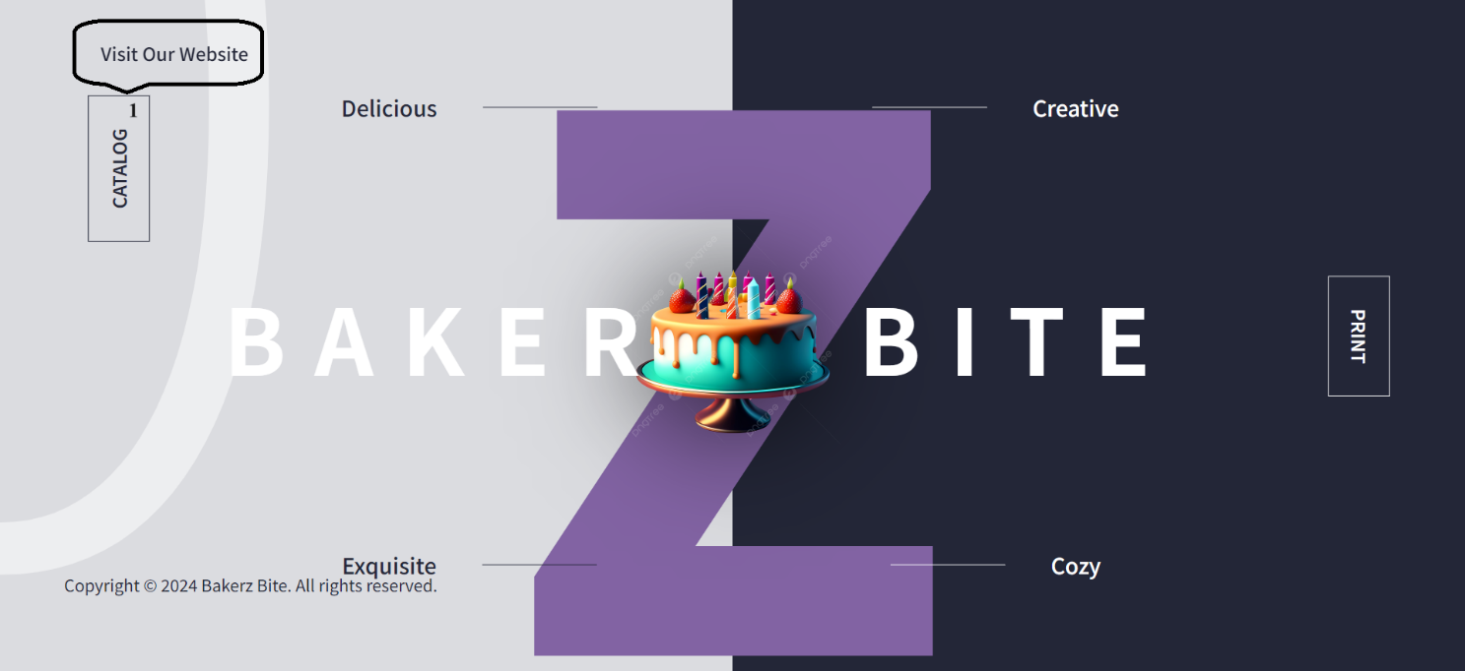

|  |  |  |  |
| --- | --- | --- | --- |
| **No** | **Type** | **Validation** | **Action** |
| 1 | Click |  | Navigation to Home page |

**II. Home page**

The homepage of Bakerz Bite serves as a comprehensive introduction to our bakery, offering detailed information about our diverse range of high-quality pastries and exceptional services, ensuring a delightful and memorable experience for our customers.

**2.1. Navbar and Slide Main**

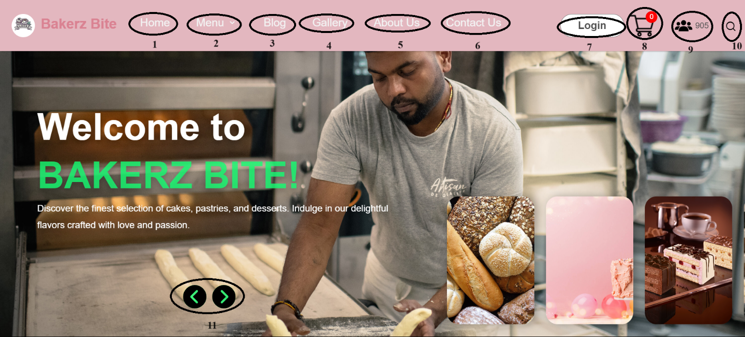

|  |  |  |  |
| --- | --- | --- | --- |
| **No** | **Type** | **Validation** | **Action** |
| 1 | Click |  | Redirect to Home page |
| 2 | Click |  | Navigate to Menu page |
| 3 | Click |  | Navigate to Blog page |
| 4 | Click |  | Navigate to Gallery page |
| 5 | Click |  | Navigate to About Us page |
| 6 | Click |  | Navigate to Contact Us page |
| 7 | Click |  | Navigate to Login page |
| 8 | Click |  | Navigate to Cart Item page |
| 9 | Mount |  | Display the number of website visitors. |
| 10 | Click |  | Search products |
| 11 | Click |  | Move the image slider. |

**2.2. About Us section, New products section and Top selling section**

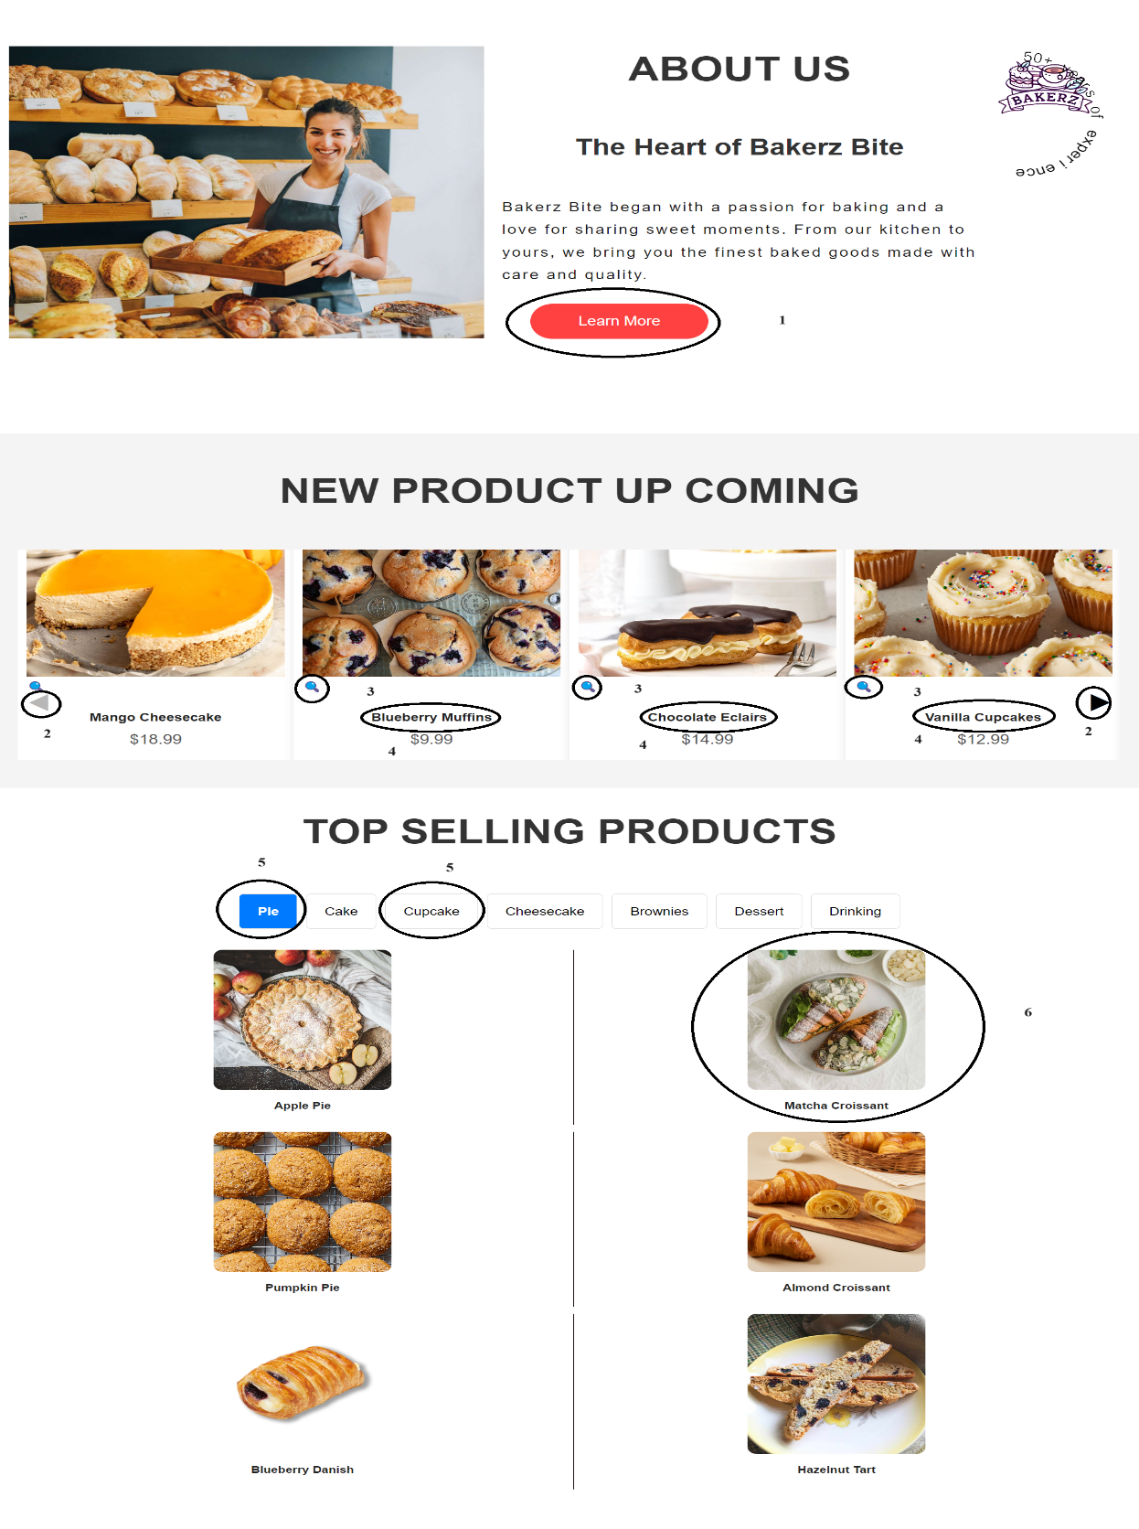

|  |  |  |  |
| --- | --- | --- | --- |
| **No** | **Type** | **Validation** | **Action** |
| 1 | Click |  | Navigate to About Us page |
| 2 | Click |  | Move the image slider |
| 3 | Click |  | Enlarge the image |
| 4 | Click |  | Display the image and product description |
| 5 | Click |  | Display products by category |
| 6 | Click |  | Navigate to the product display page by clicking on the image or product name |

**2.** **3. Our baker section, Why choose us section and Promotion section**

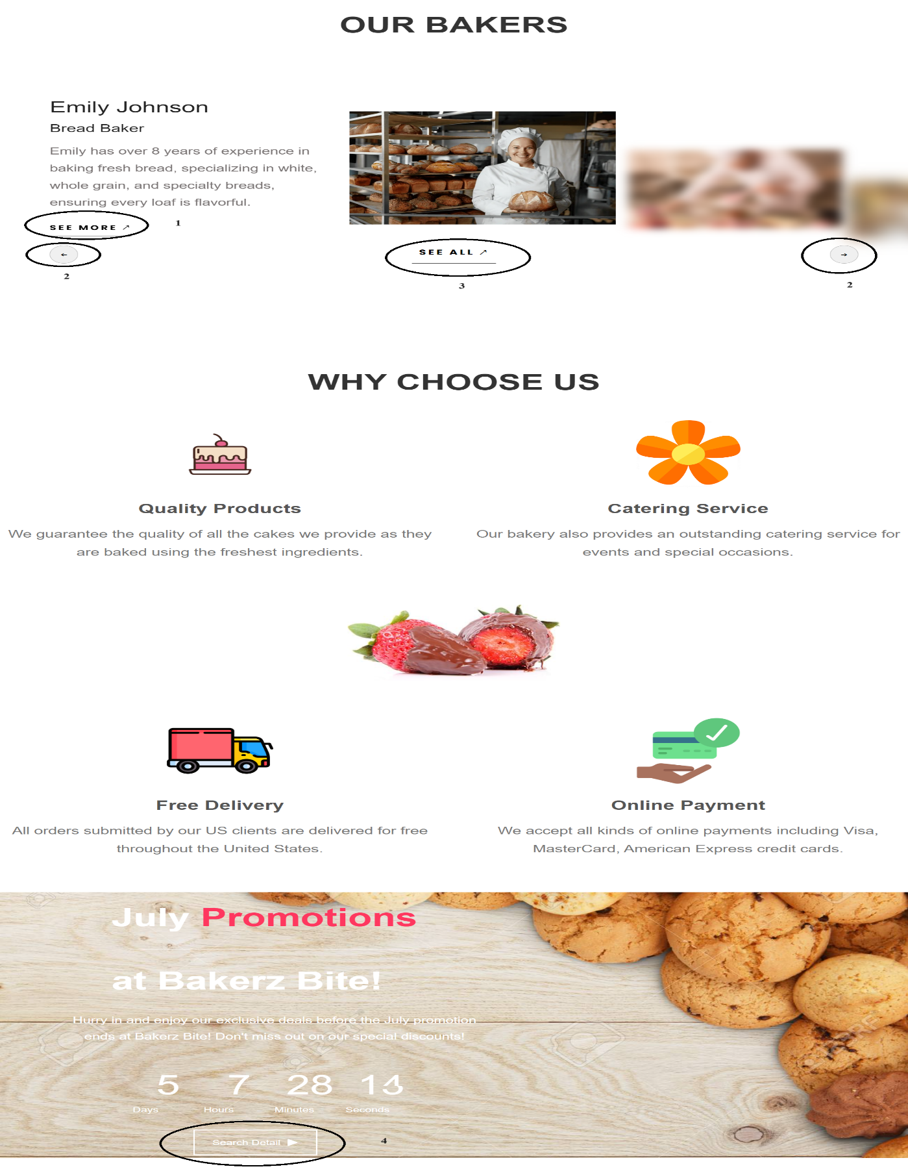

|  |  |  |  |
| --- | --- | --- | --- |
| **No** | **Type** | **Validation** | **Action** |
| 1 | Click |  | View detailed information about the baker |
| 2 | Click |  | Move the image slider |
| 3 | Click |  | View all information about the baker |
| 4 | Click |  | View detailed information about the promotion program |

**2.4. Blog section, Testimonial section and Newsletter section**

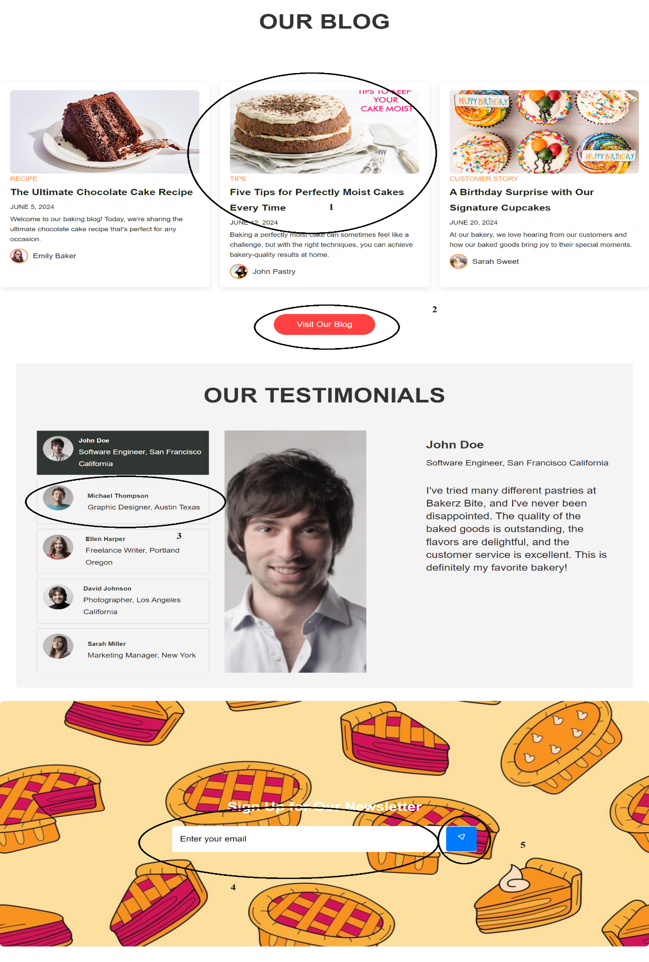

|  |  |  |  |
| --- | --- | --- | --- |
| **No** | **Type** | **Validation** | **Action** |
| 1 | Click |  | Navigate to the detailed article page |
| 2 | Click |  | Navigate to Blog page |
| 3 | Click |  | View customer comments |
| 4 | Type |  | Enter email |
| 5 | Click |  | Send email (After sending the email, a confirmation notification will appear to indicate the email was sent successfully) |

**An email will be sent to the inbox**

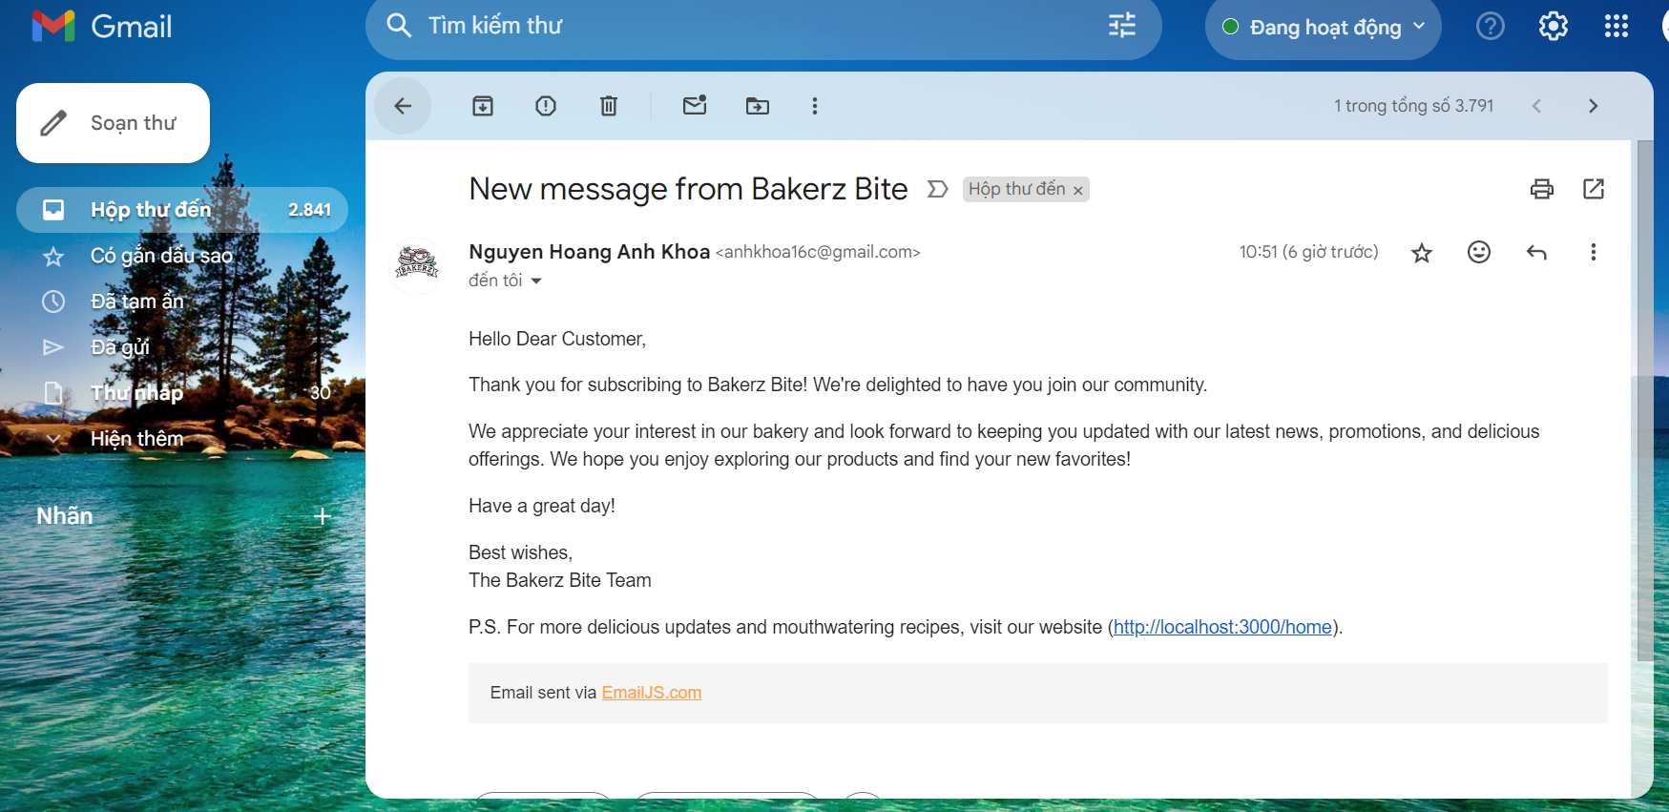

**2.5. Footer section**

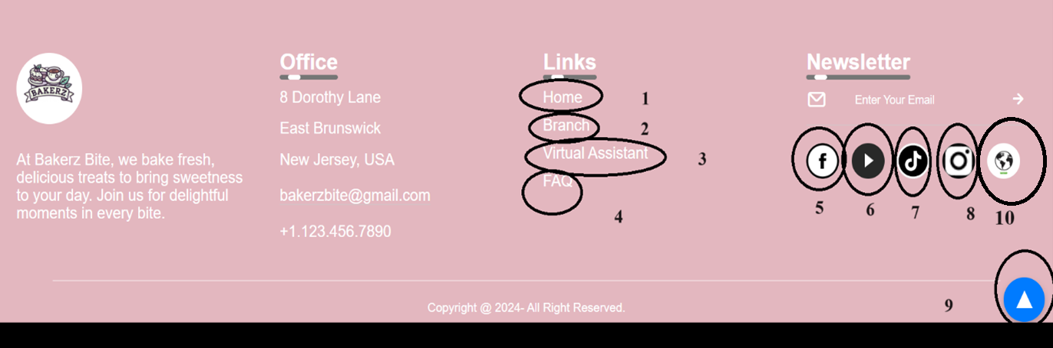

|  |  |  |  |
| --- | --- | --- | --- |
| **No** | **Type** | **Validation** | **Action** |
| 1 | Click |  | Redirect to Home page |
| 2 | Click |  | Navigate to Branch page |
| 3 | Click |  | Navigate to chatbot (AI voice) |
| 4 | Click |  | Navigate to FAQ page |
| 5 | Click |  | Navigate to Facebook page |
| 6 | Click |  | Navigate to Youtube page |
| 7 | Click |  | Navigate to Tiktok page |
| 8 | Click |  | Navigate to Instagram page |
| 9 | Click |  | Back to top |
| 10 | Click |  | Translate into any language |

**III-Menu Page**

The menu page introduces the bakery's products and beverages available for purchase.

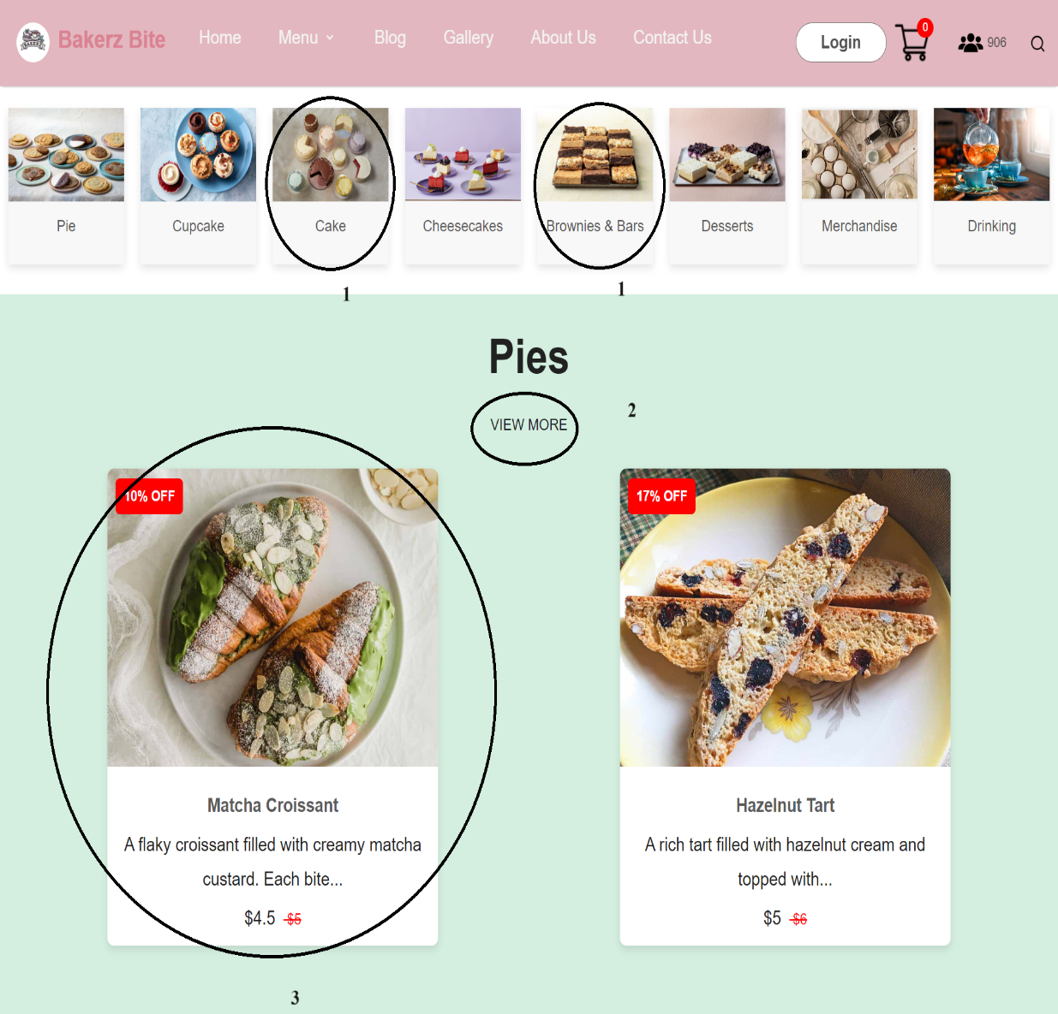

|  |  |  |  |
| --- | --- | --- | --- |
| **No** | **Type** | **Validation** | **Action** |
| 1 | Click |  | Navigate to the section containing categorized products |
| 2 | Click |  | Navigate to Products page by category |
| 3 | Click |  | Navigate to Product detail page |

**IV-Product page**

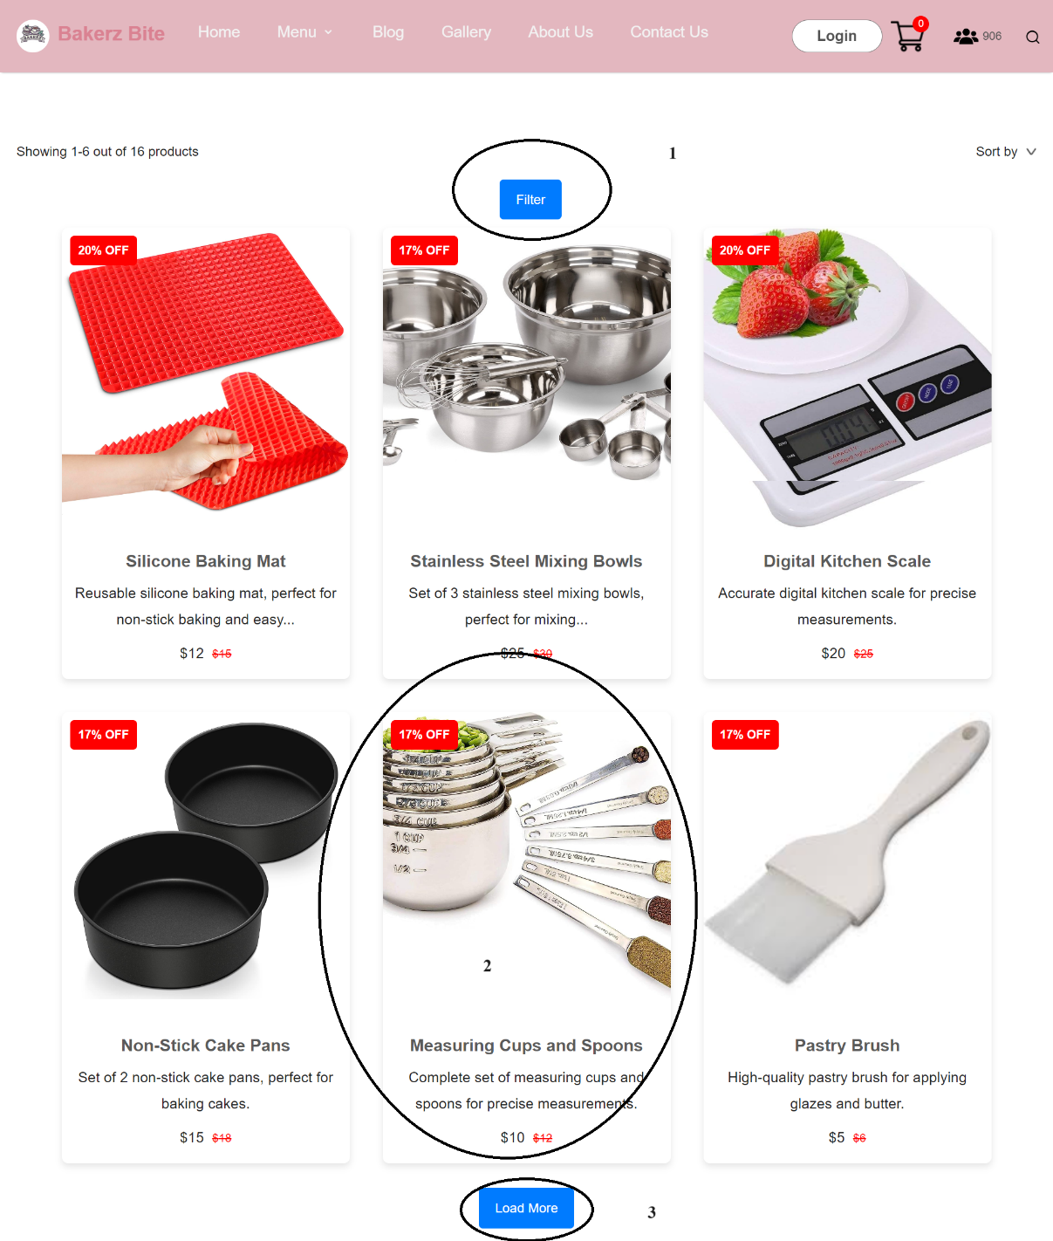

|  |  |  |  |
| --- | --- | --- | --- |
| **No** | **Type** | **Validation** | **Action** |
| 1 | Click |  | Display product filters using hashtags and checkboxes |
| 2 | Click |  | Navigate to Product detail page |
| 3 | Click |  | Display more products |

**V-Product detail page**

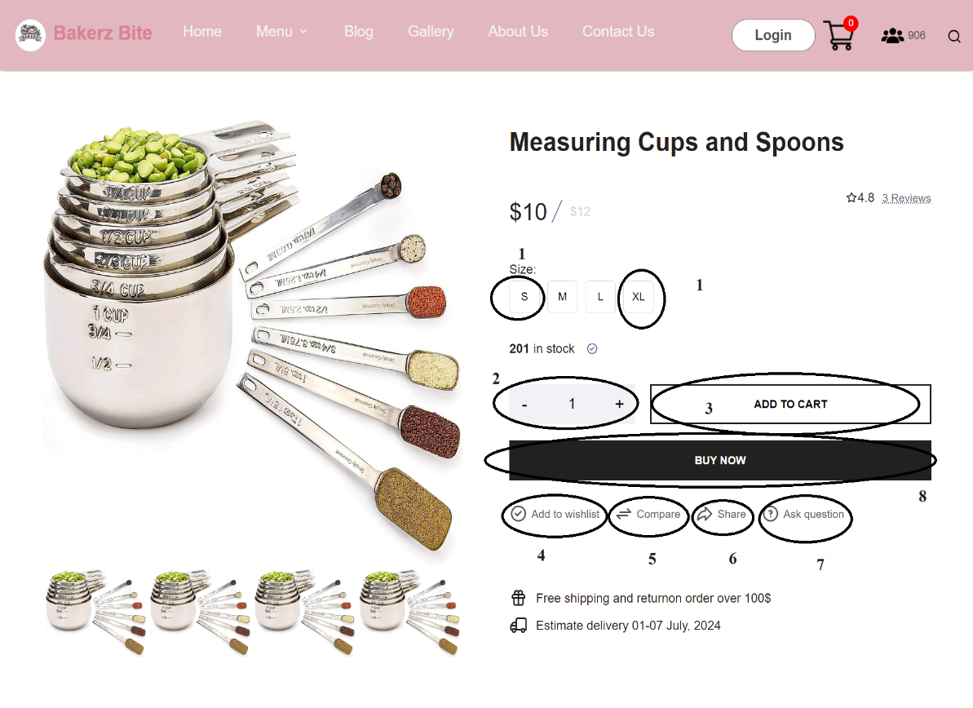

|  |  |  |  |
| --- | --- | --- | --- |
| **No** | **Type** | **Validation** | **Action** |
| 1 | Click |  | Select cake size |
| 2 | Click |  | Increase or decrease the quantity of products to purchase |
| 3 | Click |  | Add product to cart |
| 4 | Click |  | Add product to the wishlist (after logging into the account, the "My Cake" button will appear, which contains the favorite products) |
| 5 | Click |  | Display product comparison table |
| 6 | Click |  | Display the product link, when clicking on the share icons, allow sharing the link on the corresponding social media platforms |
| 7 | Click |  | Allow users to leave their name, email address, and questions for the store to respond |
| 8 | Click |  | Navigate directly to Payment page |

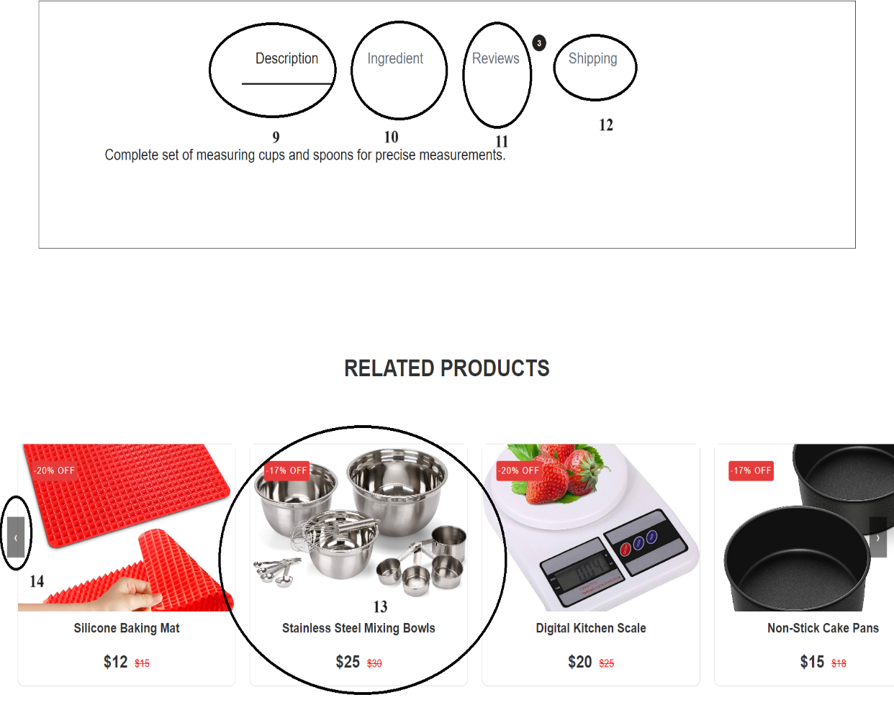

|  |  |  |  |
| --- | --- | --- | --- |
| **No** | **Type** | **Validation** | **Action** |
| 9 | Click |  | Display the product description |
| 10 | Click |  | Display the ingredients used to make the product |
| 11 | Click |  | Display customer comments |
| 12 | Click |  | Display shipping information |
| 13 | Click |  | Display alternative products for the currently showcased item |
| 14 | Click |  | Slide images back and forth |

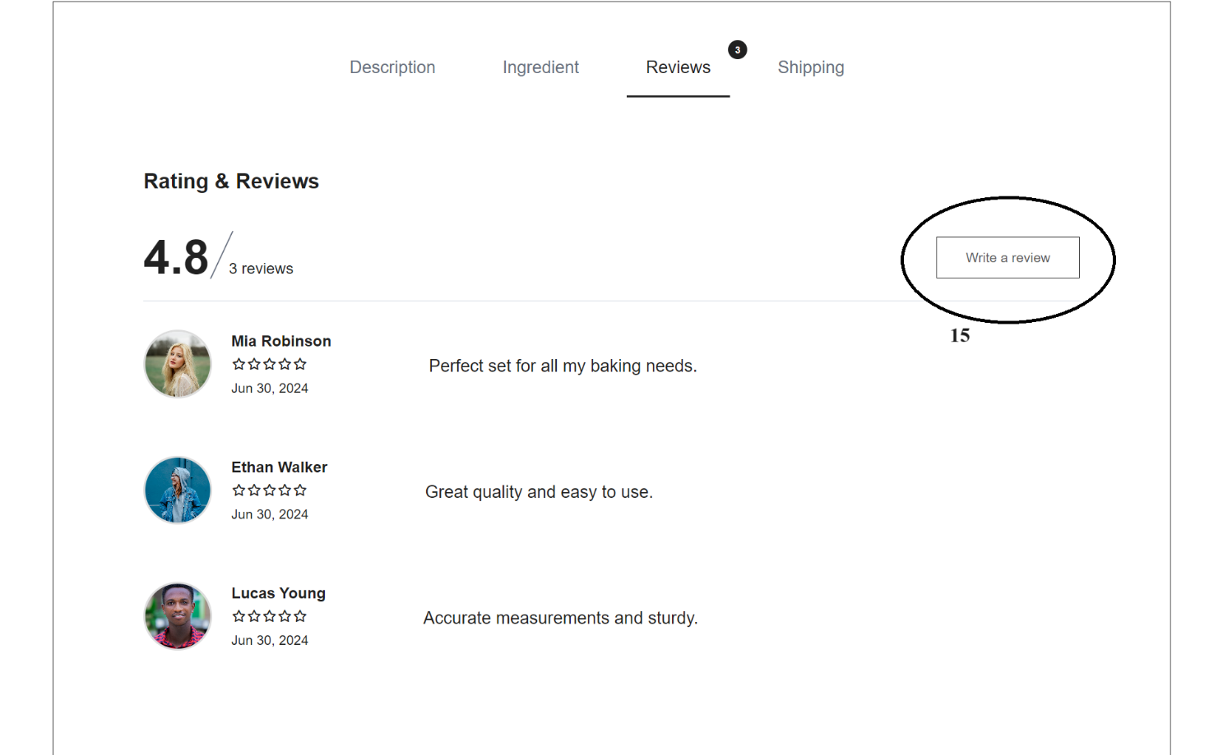

|  |  |  |  |
| --- | --- | --- | --- |
| **No** | **Type** | **Validation** | **Action** |
| 15 | Click |  | Display a form for users to enter their name, email, star rating, and comment. After clicking the send button, the comment will be displayed |

**VI-Cart page**

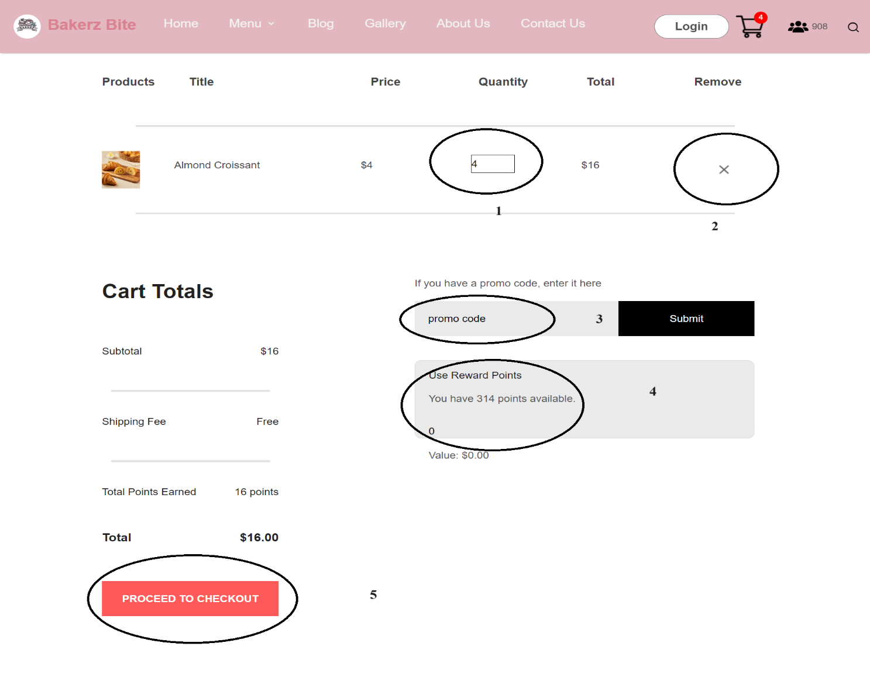

|  |  |  |  |
| --- | --- | --- | --- |
| **No** | **Type** | **Validation** | **Action** |
| 1 | Click |  | Increase or decrease the quantity of products to purchase |
| 2 | Click |  | Remove product if no longer purchasing |
| 3 | Click |  | Enter promo code (if purchasing $20 or more, a promo code will appear to enter) |
| 4 | Click |  | Redeem reward points for a discount (100 points can be redeemed for $1) |
| 5 | Click |  | Navigate to Payment page |

**VII-Payment page**

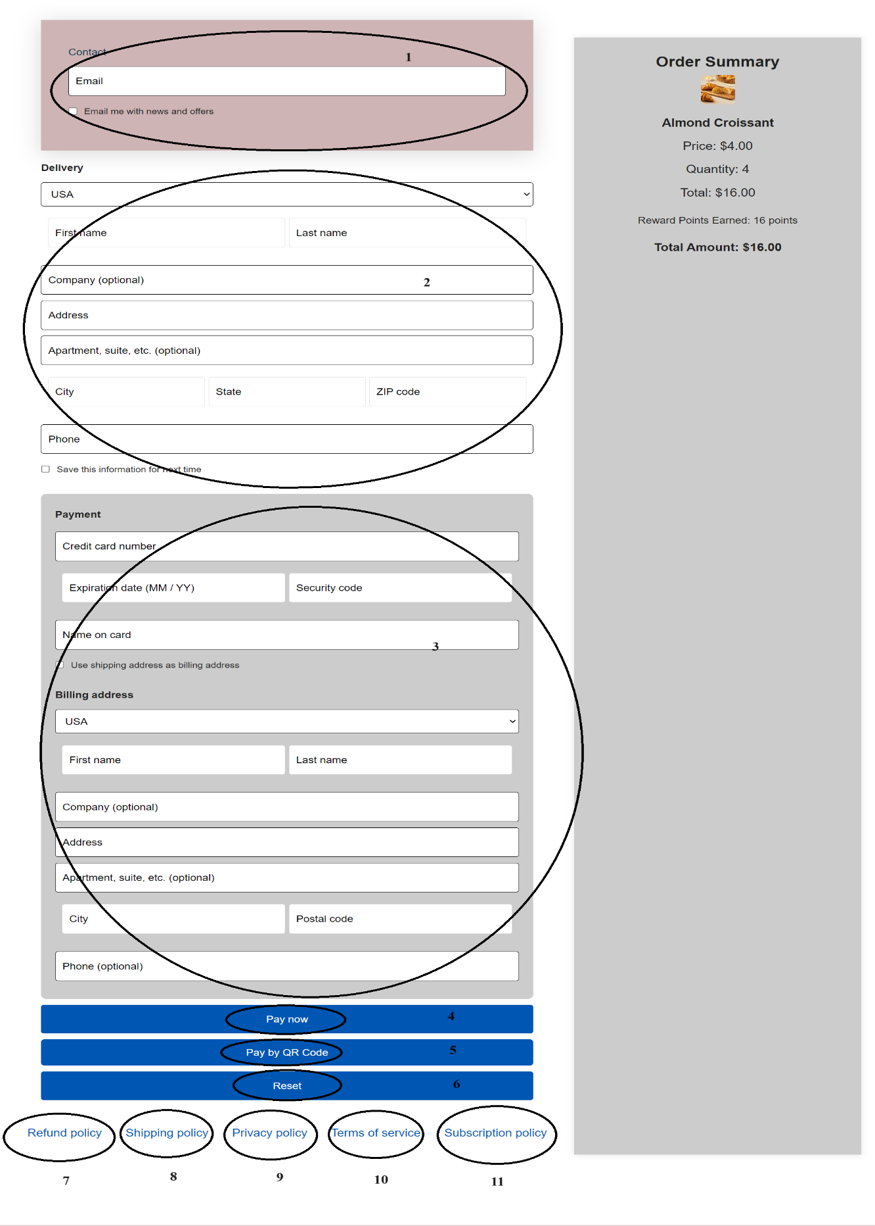

|  |  |  |  |
| --- | --- | --- | --- |
| **No** | **Type** | **Validation** | **Action** |
| 1 | Type |  | Enter email address |
| 2 | Type |  | Form for entering delivery information |
| 3 | Type |  | Form for entering credit card payment information |
| 4 | Click |  | Button to place order |
| 5 | Click |  | Button to display QR code for payment scanning |
| 6 | Click |  | Button to reset information |
| 7 | Click |  | Button to display a pop-up window showing the refund policy |
| 8 | Click |  | Button to display a pop-up window showing the shipping policy |
| 9 | Click |  | Button to display a pop-up window showing the privacy policy |
| 10 | Click |  | Button to display a pop-up window showing the term of service |
| 11 | Click |  | Button to display a pop-up window showing the subscription policy |

**VIII-Login page**

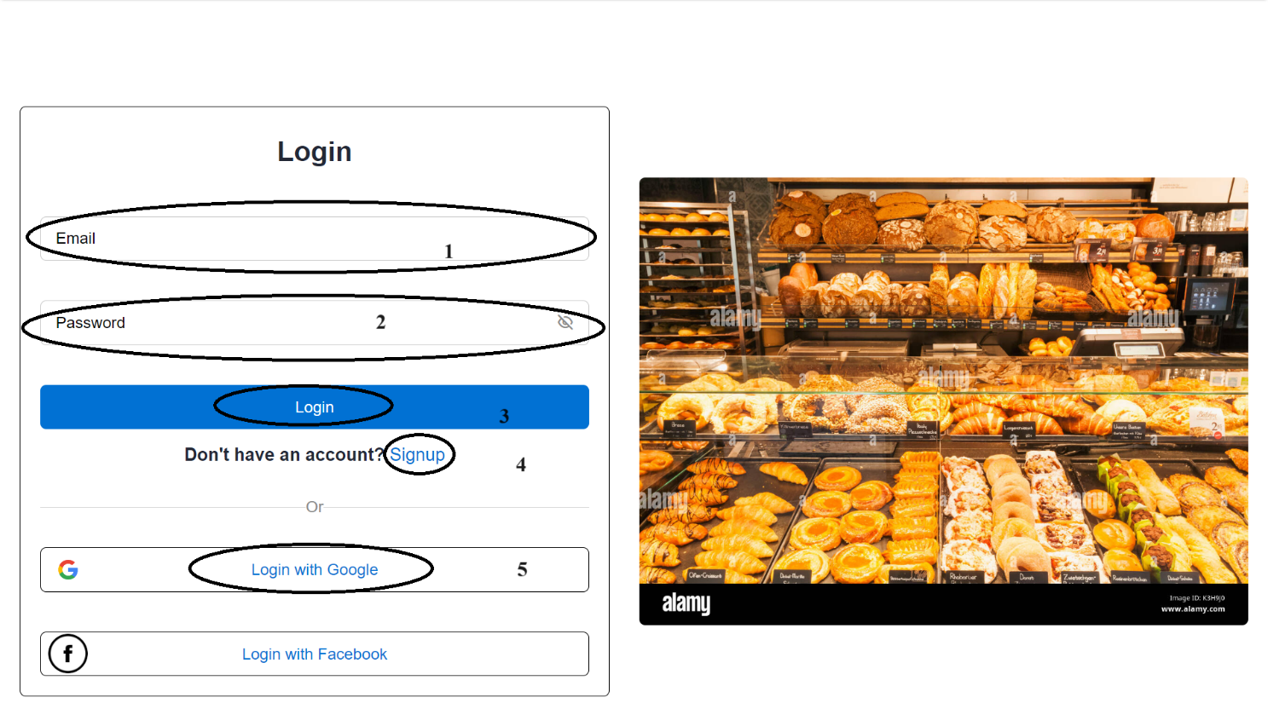

|  |  |  |  |
| --- | --- | --- | --- |
| **No** | **Type** | **Validation** | **Action** |
| 1 | Type |  | Enter email address |
| 2 | Type |  | Display password (click the eye icon to view the password) |
| 3 | Click |  | After entering email and password, click the login button to sign into the account. |
| 4 | Click |  | Navigate to the signup page if you don't have an account |
| 5 | Click |  | Log in with your Gmail account if you don't want to create a new account |

**IX- SignUp page**

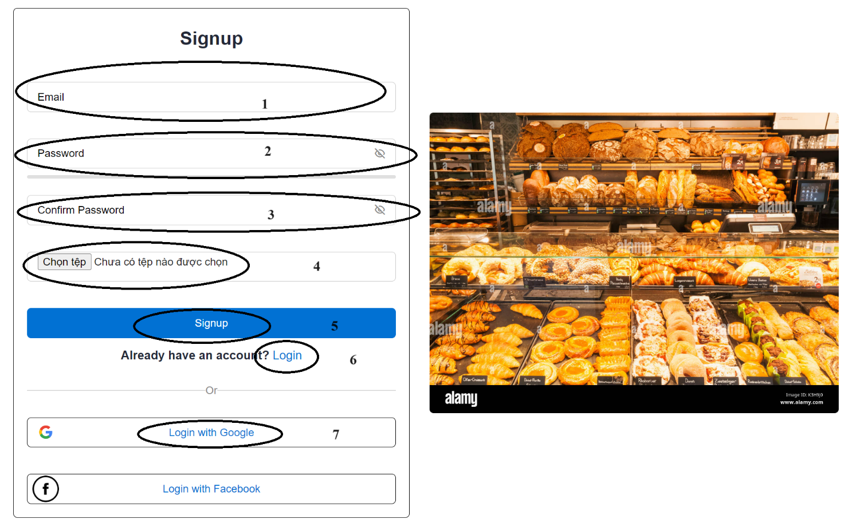

|  |  |  |  |
| --- | --- | --- | --- |
| **No** | **Type** | **Validation** | **Action** |
| 1 | Type |  | Enter email address |
| 2 | Type |  | Display password (click the eye icon to view the password) |
| 3 | Type |  | Confirm password (click the eye icon to view the password) |
| 4 | Click |  | Upload an image to use as your account's profile picture |
| 5 | Click |  | After entering your email, setting a password, and uploading an image, click the signup button (a notification will appear to inform you that your account has been successfully created) |
| 6 | Click |  | Return to the login page |
| 7 | Click |  | Log in with your Gmail account |

**X-Blog page**

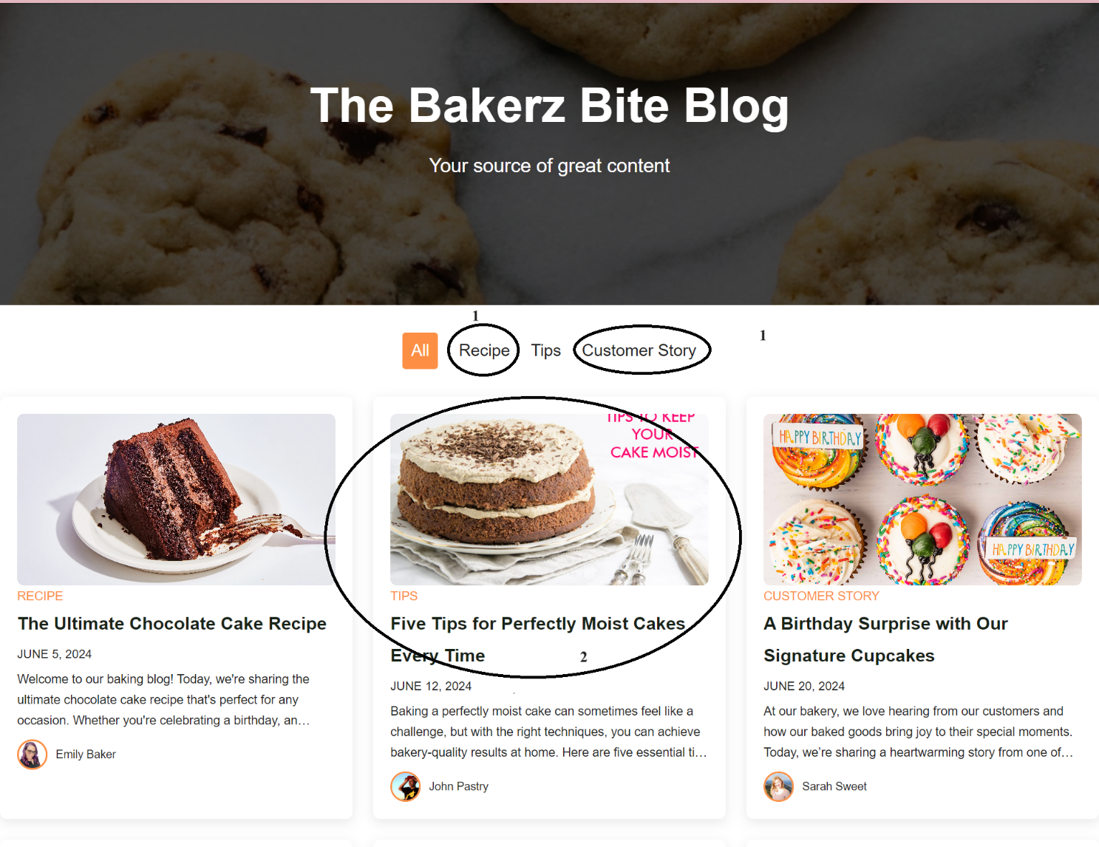

|  |  |  |  |
| --- | --- | --- | --- |
| **No** | **Type** | **Validation** | **Action** |
| 1 | Click |  | Display posts by category |
| 2 | Click |  | Go to the detailed post page |

**XI-Detailed post page**

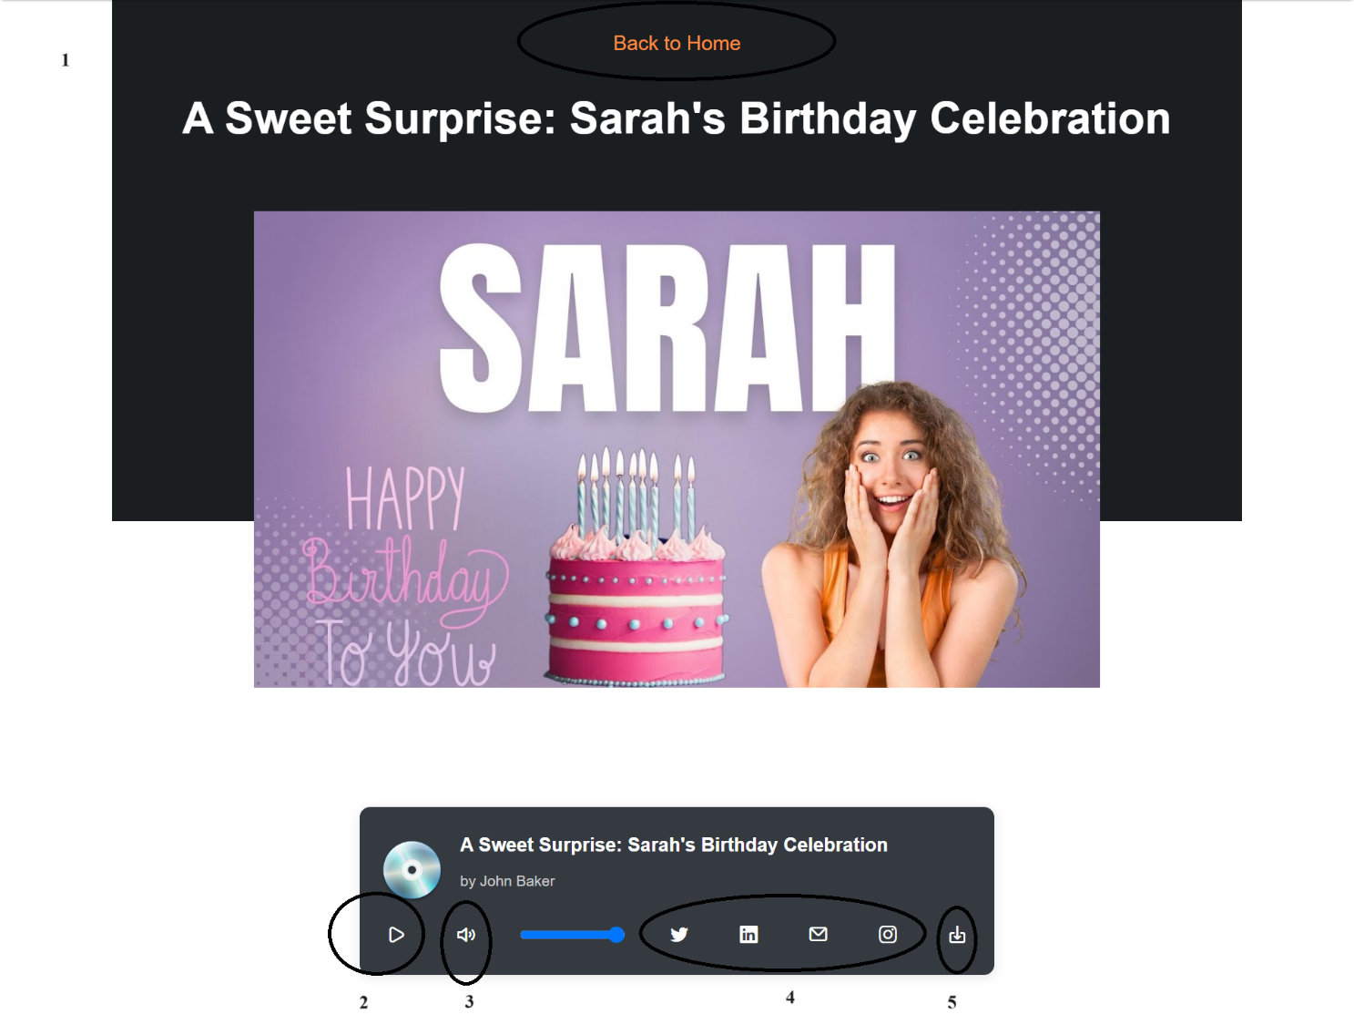

|  |  |  |  |
| --- | --- | --- | --- |
| **No** | **Type** | **Validation** | **Action** |
| 1 | Click |  | Redirect to Blog page |
| 2 | Click |  | Open audio file |
| 3 | Click |  | Increase or decrease volume |
| 4 | Click |  | Share audio file on social media platforms |
| 5 | Click |  | Download audio |

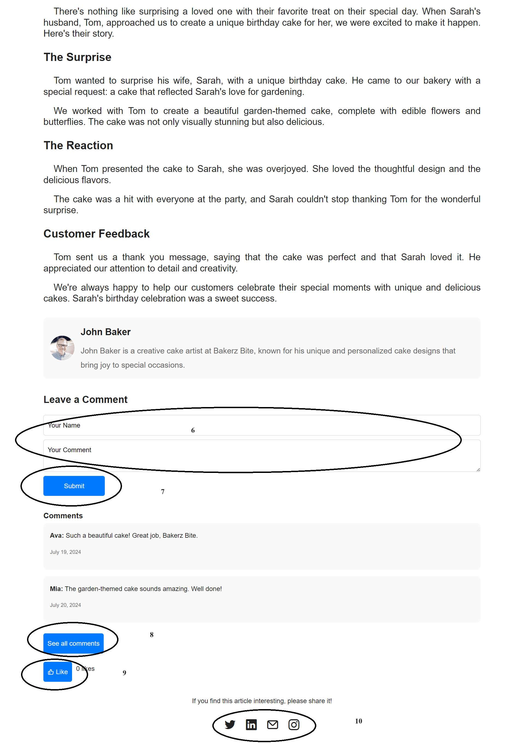

|  |  |  |  |
| --- | --- | --- | --- |
| **No** | **Type** | **Validation** | **Action** |
| 6 | Type |  | Enter email and comment |
| 7 | Click |  | Submit comment (Even when the page remounts, your comments will not disappear) |
| 8 | Click |  | Display all comments |
| 9 | Click |  | Show likes (Even when the page remounts, your likes will not disappear) |
| 10 | Click |  | Share the post on social media platforms |

**XII-Gallery page**

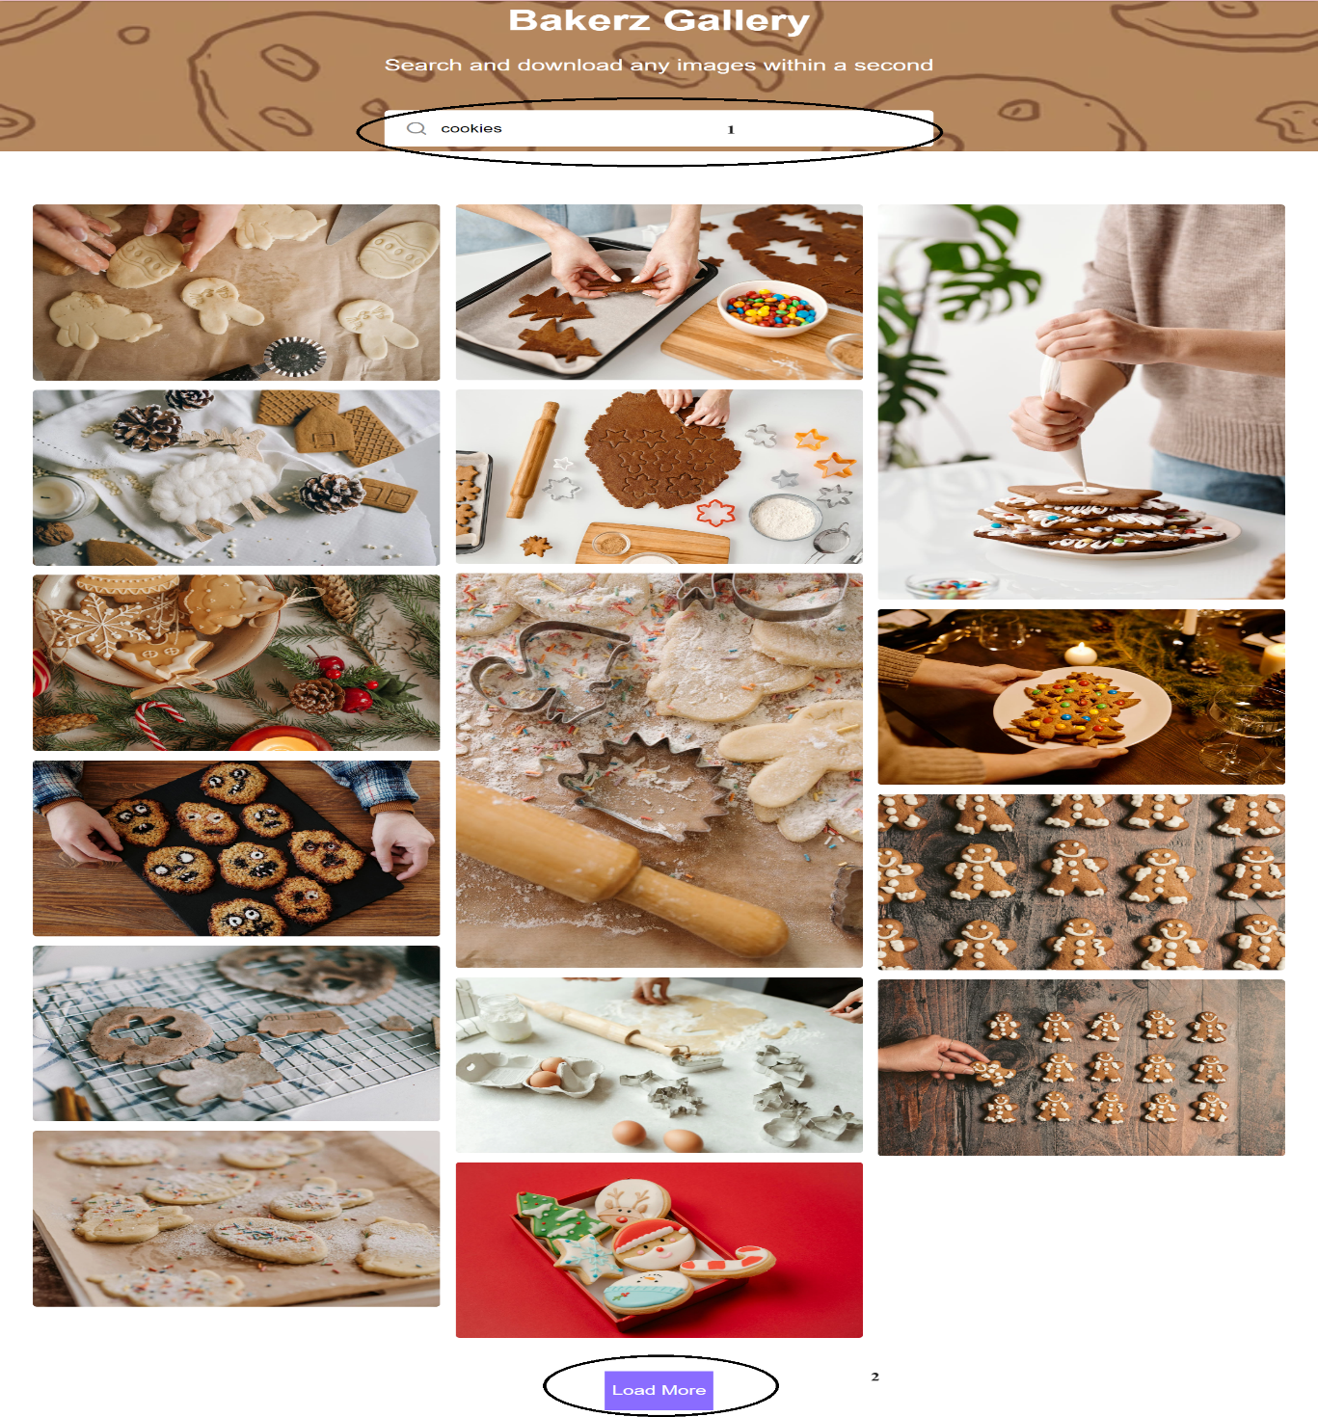

|  |  |  |  |
| --- | --- | --- | --- |
| **No** | **Type** | **Validation** | **Action** |
| 1 | Type |  | Enter keywords to search for the image |
| 2 | Click |  | Display more images |

When click on an image, a lightbox containing that image will appear.

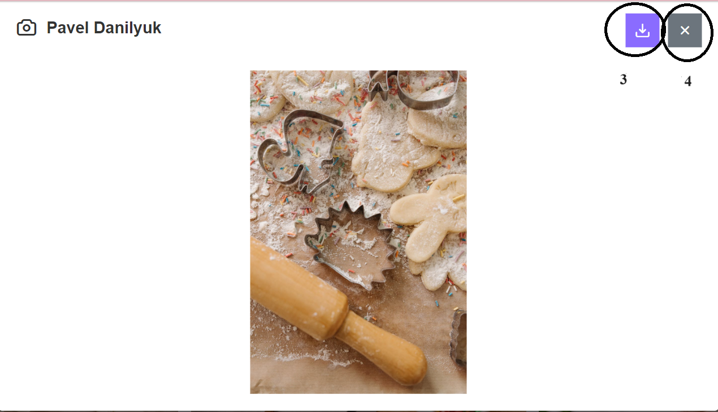

|  |  |  |  |
| --- | --- | --- | --- |
| **No** | **Type** | **Validation** | **Action** |
| 3 | Click |  | Download image |
| 4 | Click |  | Close image |

**XIII-About Us page**

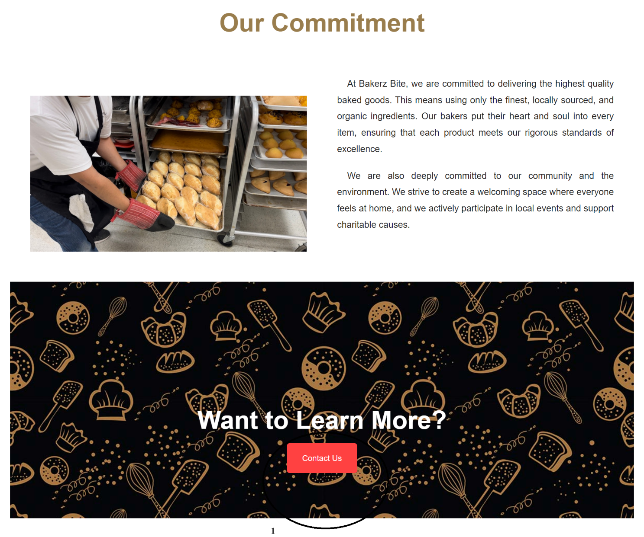

|  |  |  |  |
| --- | --- | --- | --- |
| **No** | **Type** | **Validation** | **Action** |
| 1 | Click |  | Navigate to Contact Us page |

**XIV-Contact Us page**

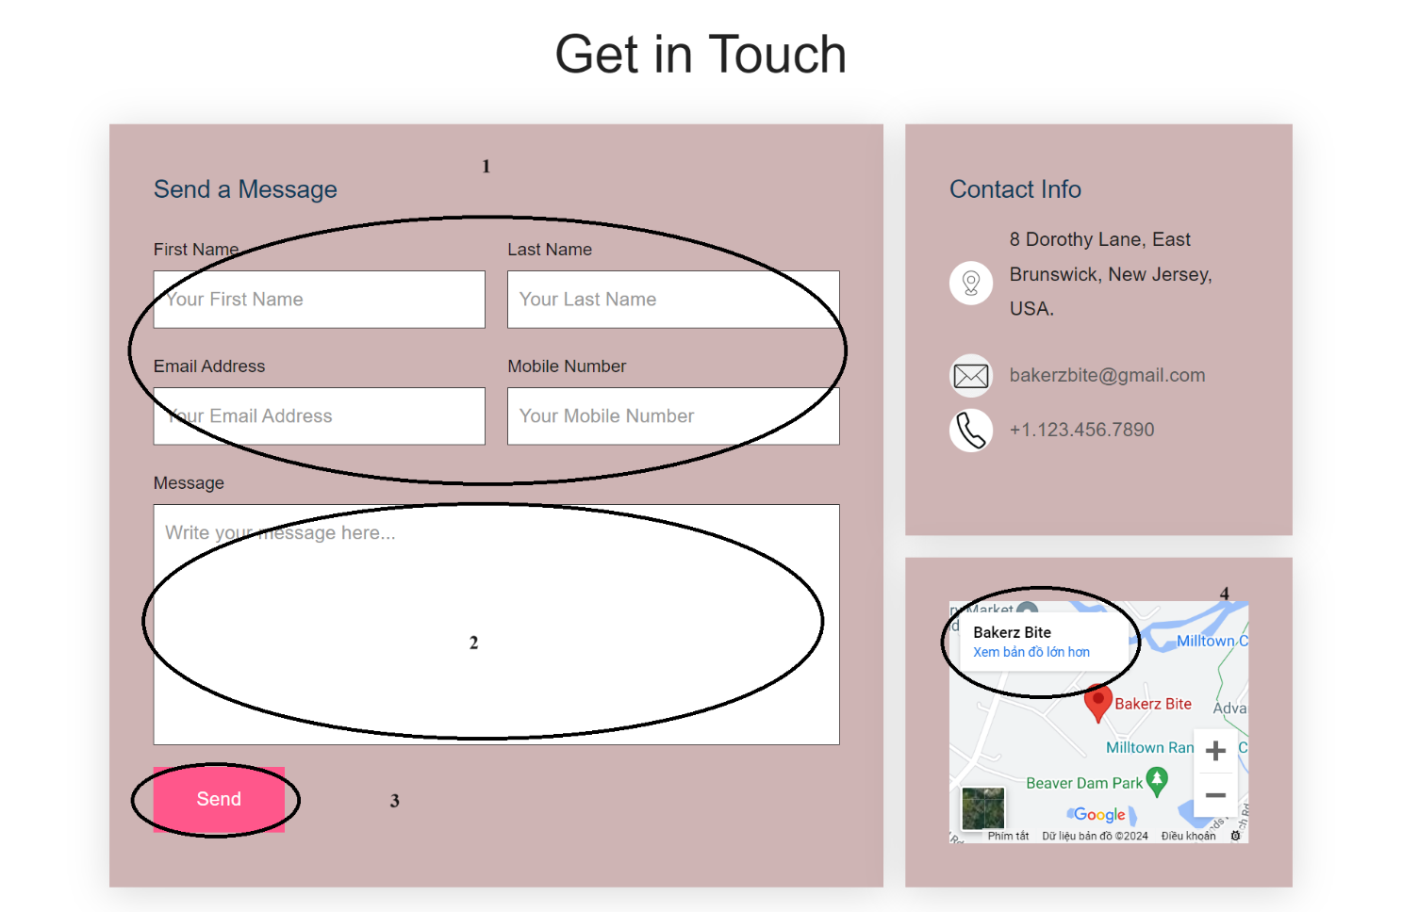

|  |  |  |  |
| --- | --- | --- | --- |
| **No** | **Type** | **Validation** | **Action** |
| 1 | Type |  | Enter first name, last name, email and phone number. |
| 2 | Type |  | Enter message |
| 3 | Click |  | Send message |
| 4 | Click |  | Open Google Maps to view a more detailed map |

After sending the message, there will be a confirmation notification that the message has been sent successfully and the store will receive the customer’s message.

**XV-Order History page**

The Order History page will appear after the customer has successfully registered an account, and the Login button on the navbar will change to Account button.

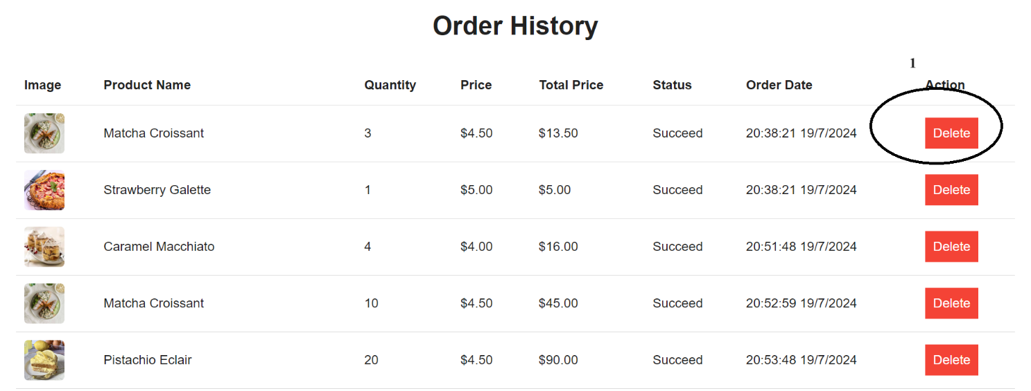

|  |  |  |  |
| --- | --- | --- | --- |
| **No** | **Type** | **Validation** | **Action** |
| 1 | Click |  | Delete the history of a product that the customer has purchased |

**XVI-My Cake page**

The My Cake page will appear after the customer has successfully registered an account, and the Login button on the navbar will change to Account button.

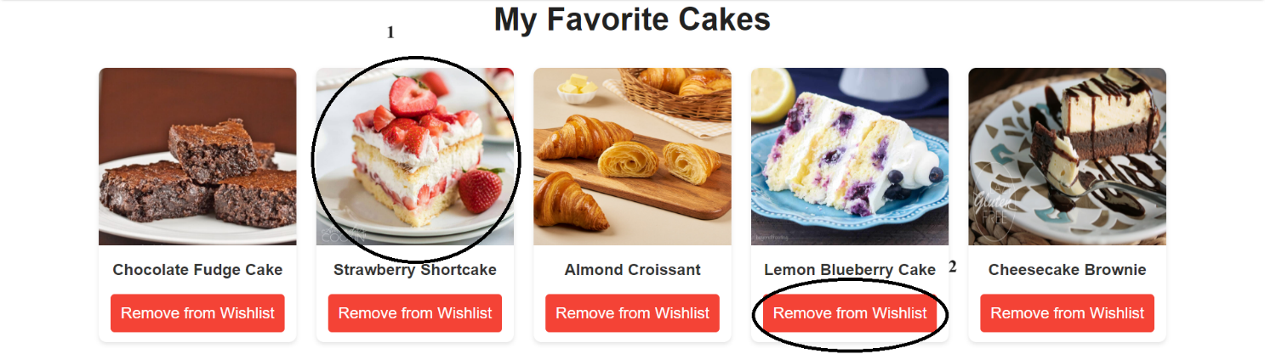

|  |  |  |  |
| --- | --- | --- | --- |
| **No** | **Type** | **Validation** | **Action** |
| 1 | Click |  | Display the selected product on the product detail page |
| 2 | Click |  | Remove the product from the wishlist |

**XVI-User page**

The User page will appear after the customer has successfully registered an account, and the Login button on the navbar will change to Account button.

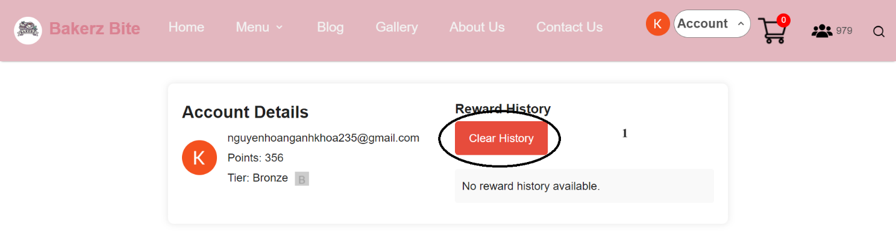

|  |  |  |  |
| --- | --- | --- | --- |
| **No** | **Type** | **Validation** | **Action** |
| 1 | Click |  | Clear usage history and reward points. When the **Clear History** button is clicked, a confirmation message will appear asking if the customer is sure they want to delete the history |

**XVII-Branch page**

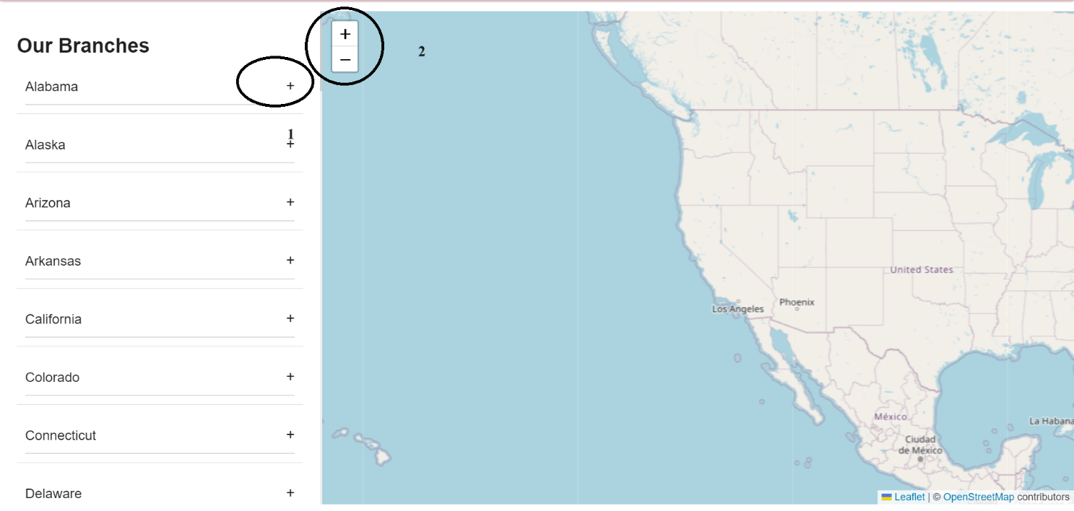

|  |  |  |  |
| --- | --- | --- | --- |
| **No** | **Type** | **Validation** | **Action** |
| 1 | Click |  | Display the address and phone number of the branch |
| 2 | Click |  | Zoom in and zoom out the map |

**XVIII- Virtual Assistant page**

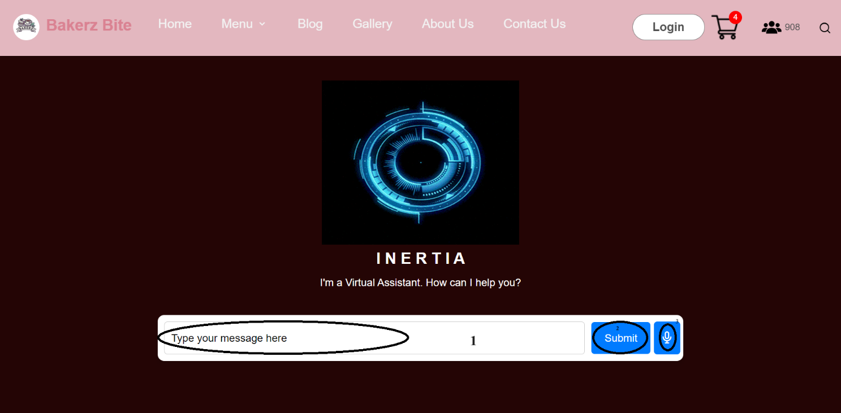

|  |  |  |  |
| --- | --- | --- | --- |
| **No** | **Type** | **Validation** | **Action** |
| 1 | Type |  | Enter the question you need answered |
| 2 | Click |  | Click the button to submit the question |
| 3 | Click |  | Use voice to ask the virtual assistant |

**XIX-FAQ page**

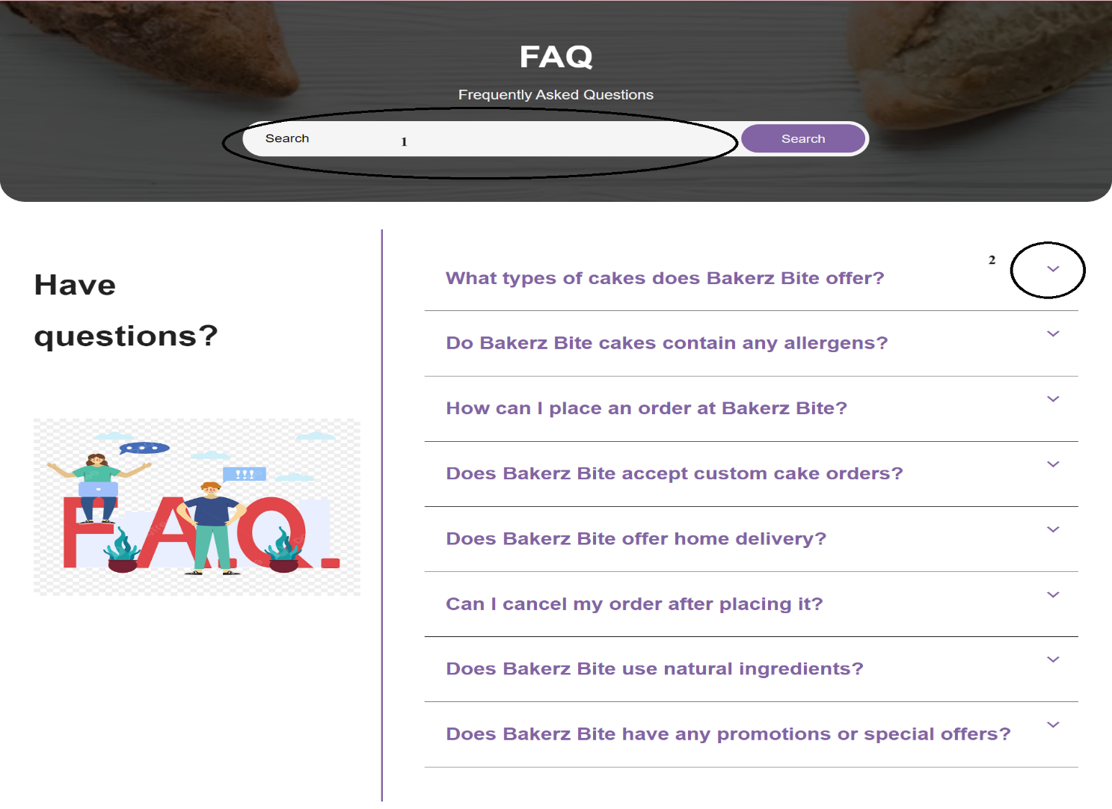

|  |  |  |  |
| --- | --- | --- | --- |
| **No** | **Type** | **Validation** | **Action** |
| 1 | Type |  | Enter the question to search, the results will be displayed and the keyword in the search results will be highlighted in yellow |
| 2 | Click |  | Open to view the answer |

**Task Sheet**

|  |  |  |  |  |  |  |  |
| --- | --- | --- | --- | --- | --- | --- | --- |
| **No** | **Member** | | **Page Name** | **Planed Start Date** | **Actual Start Date** | **Actual End Date** | **Status** |
| *1.* | | *NGUYỄN HOÀNG ANH KHOA* | **Home** | 22/06/2024 | 23/06/2024 | 26/07/2024 | **100%** |
| **Facebook** | 22/06/2024 | 25/06/2024 | 26/07/2024 | **100%** |
| **Virtual Assistant** | 22/06/2024 | 25/06/2024 | 26/07/2024 | **100%** |
| **Blog** | 22/06/2024 | 01/07/2024 | 26/07/2024 | **100%** |
| **Branch** | 22/06/2024 | 01/07/2024 | 26/07/2024 | **100%** |
| **Order History** | 22/06/2024 | 01/07/2024 | 26/07/2024 |  |
| **Write document** | 22/07/2024 | 26/07/2024 | 26/07/2024 | **100%** |
| *2.* | | *NGÔ QUANG KHÁNH* | **Menu** | 22/06/2024 | 24/06/2024 | 26/07/2024 | **100%** |
| **Product** | 22/06/2024 | 24/06/2024 | 26/07/2024 | **100%** |
| **Youtube** | 22/06/2024 | 28/06/2024 | 26/07/2024 | **100%** |
| **Contact Us** | 22/06/2024 | 30/06/2024 | 26/07/2024 | **100%** |
| **Edit video** | 25/06/2024 | 30/06/2024 | 26/07/2024 | **100%** |
| **My Cake** | 25/06/2024 | 30/06/2024 | 26/07/2024 | **100%** |
| **Write document** | 22/07/2024 | 26/07/2024 | 26/07/2024 | **100%** |
| *3.* | | *LÊ VĨNH KHANG* | **Product Detail** | 22/06/2024 | 24/11/2023 | 26/07/2024 | **100%** |
| **Tiktok** | 22/06/2024 | 29/11/2023 | 26/07/2024 | **100%** |
| **About Us** | 22/06/2024 | 02/07/2024 | 26/07/2024 | **100%** |
| **Single page** | 22/06/2024 | 02/07/2024 | 26/07/2024 | **100%** |
| **Write document** | 22/07/2024 | 26/07/2024 | 26/07/2024 | **100%** |
| *4.* | | *NGUYỄN ĐỨC HUY* | **Checkout** | 22/06/2024 | 24/06/2024 | 26/07/2024 | **100%** |
| **Payment** | 22/06/2024 | 24/06/2024 | 26/07/2024 | **100%** |
| **Instagram** | 22/06/2024 | 24/06/2024 | 26/07/2024 | **100%** |
| **FAQ** | 22/06/2024 | 01/07/2024 | 26/07/2024 | **100%** |
| **User** | 19/07/2024 | 25/07/2024 | 26/07/2024 | **100%** |
| **Write document** | 22/07/2024 | 26/07/2024 | 26/07/2024 | **100%** |